PHASE 6
PROJECT TESTING
INTRODUCTION:
TEAM ID : SWTID-2026-1385
TEAM LEADER: Dinesh E
MAIL ID : devilytd4@gmail.com
Team members:
NAME: | MAIL ID:
Faryad A | mohammadfaryad96126@gmail.com
Guru Prasath T | pguru4399@gmail.com
SUBASH. K | subashbalaji024@gmail.com
The project documentation states that the REST APIs can be tested using Postman or Thunder Client. The supplied screenshots are included below as testing evidence.

Register API
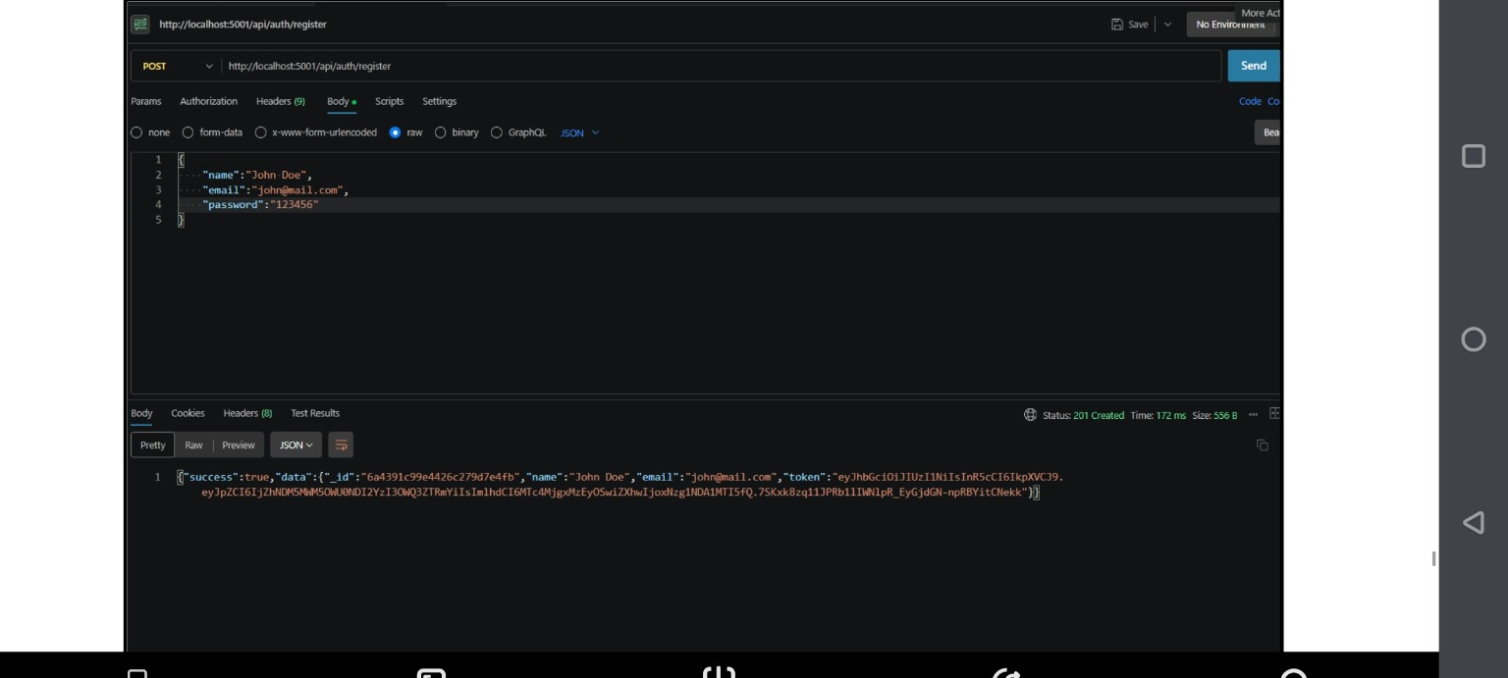
Register API — HTTP 201 Created

Weather API
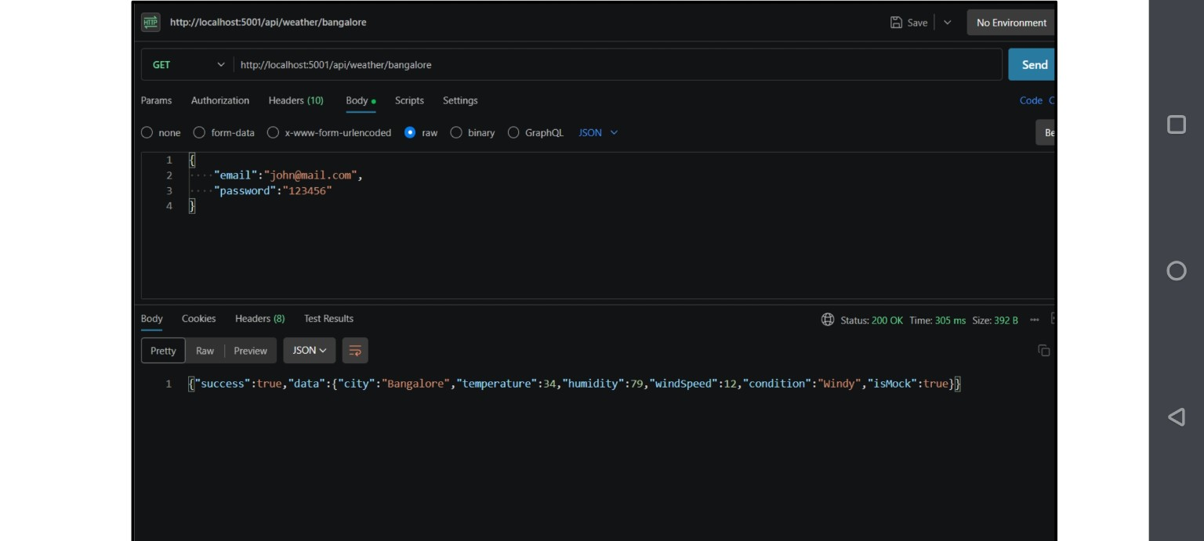
Weather API — HTTP 200 OK

Recommendation API
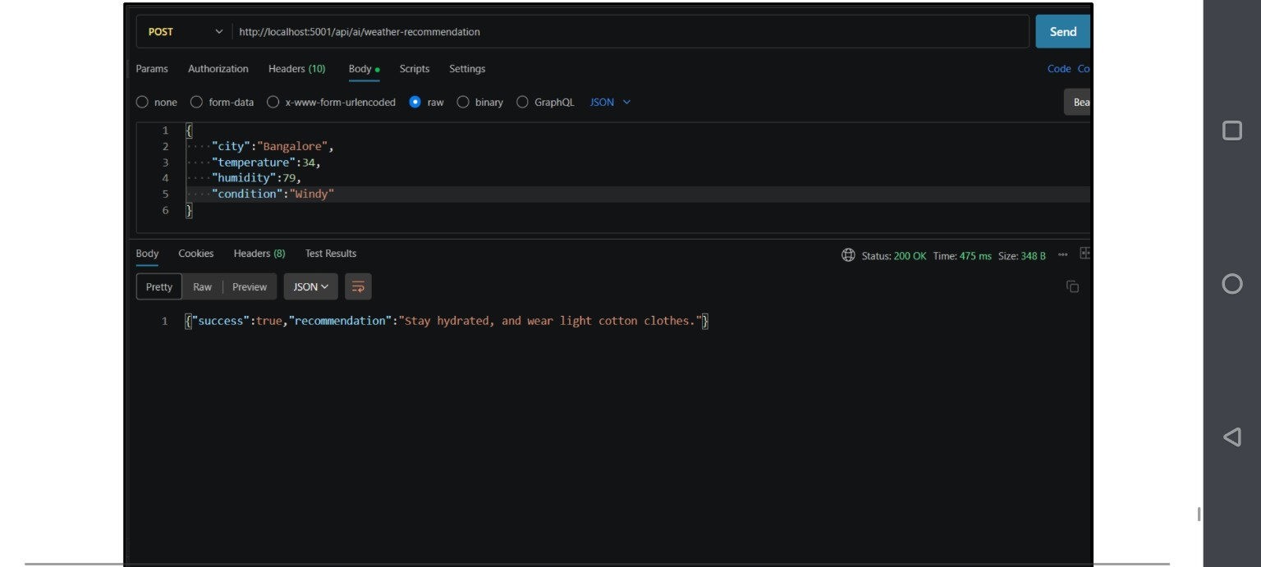
Weather Recommendation API — HTTP 200 OK
Testing result: the supplied screenshots show successful API responses for registration, weather retrieval and weather recommendation. The original documentation also lists Login API testing.

